Earthquakes
Go to recent earthquakes and mark all the earthquakes that have occurred in the last 30 days. http://www.ga.gov.au/earthquakes/recentQuakes.do?when=5&where=1&which=false&x=47&y=12
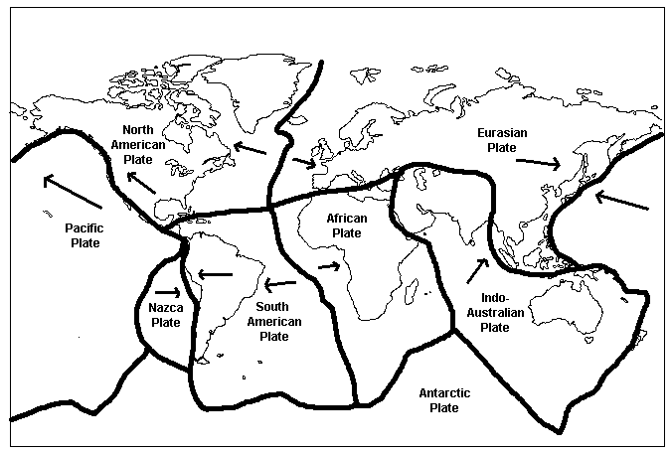
Can you notice a pattern?

What causes an earthquake?

How are earthquakes recorded?

Name two immediate effects of earthquakes and one ongoing effect.

